Timber & Battery
Timber & Battery’s playful work considers meaning and meaninglessness through oblique gestures. The collaborative practice of Rohanne Udall (London, b.1990) and Paul Hughes (Nottingham, b.1991), it takes place across choreographic, performance and visual arts contexts. Trained in fine art and philosophy, our practice is a meeting point between disciplines; a persistent and fidgeting enquiry that continually questions itself and the contexts it finds itself within.

Through formal simplicity and game-like propositions, our playful and gestural work mediates on questions we face as artists; indecisive in the face of these anxieties, we strive to skewer and sidestep through apersistence and poetic simplicity that takes place over many light and fidgety works. We are attracted to a certain weakness (weak positions, weak gestures, weak ideas and weak images), aligning ourselves with a history of critical and conceptual practice while directly borrowing from the figure and physicality of the fool. We are idiots, stumbling into situations which appear to confound us; forcing ourselves to playfully adapt in the hope of generating liberating new possibilities. Each individual work resists being reduced to any fixed and communicative message, our practice rather foregrounding the complex materiality of the body – fleshy, uncertain, demanding, awkward, restless, lethargic, playful, and deeply political.

Within a climate of austerity and neoliberalism, the artistic and experimental performance scene announce their political utility as sites of assembly, exchange, expression and critique. However, in rejection of a society that calls for productivity, stringency and accountability, we resolutely defend art’s potential to remain wasteful and non-instrumentalized – a waste of energy, time, space and possibility. Insisting on the most oblique of gestures, and floating in an interdisciplinary void, we assert the continued significance of strategies of insignificance and meaninglessness. We embrace the contradictions of valuing uselessness and pursuing meaningless, and remain curious, playful, and suspicious.

www.timberandbattery.com
paul@timberandbattery.com | rohanne@timberandbattery.com

Shelf (2017)
Found timber and screws. Approx 50cm x 50cm
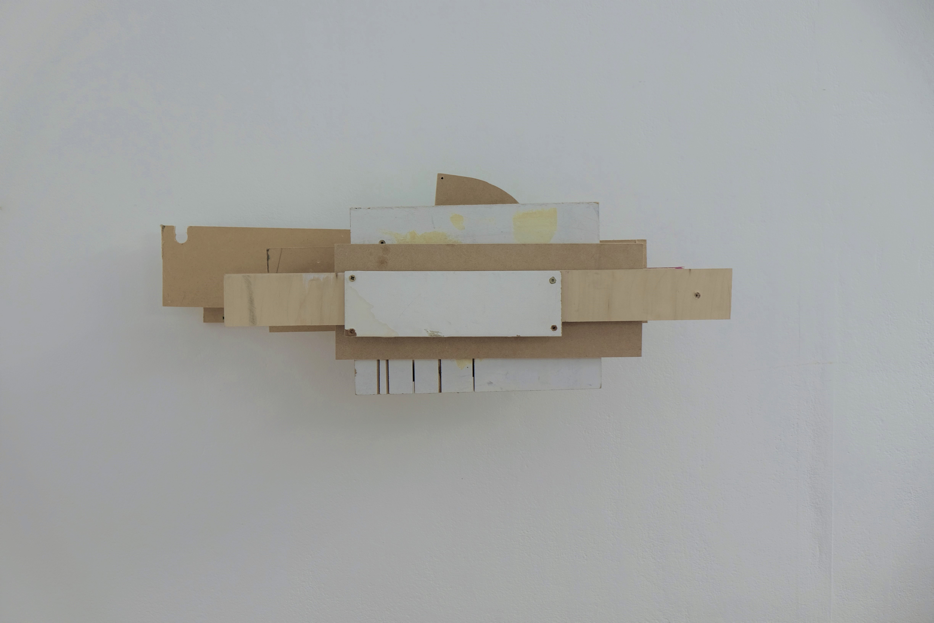
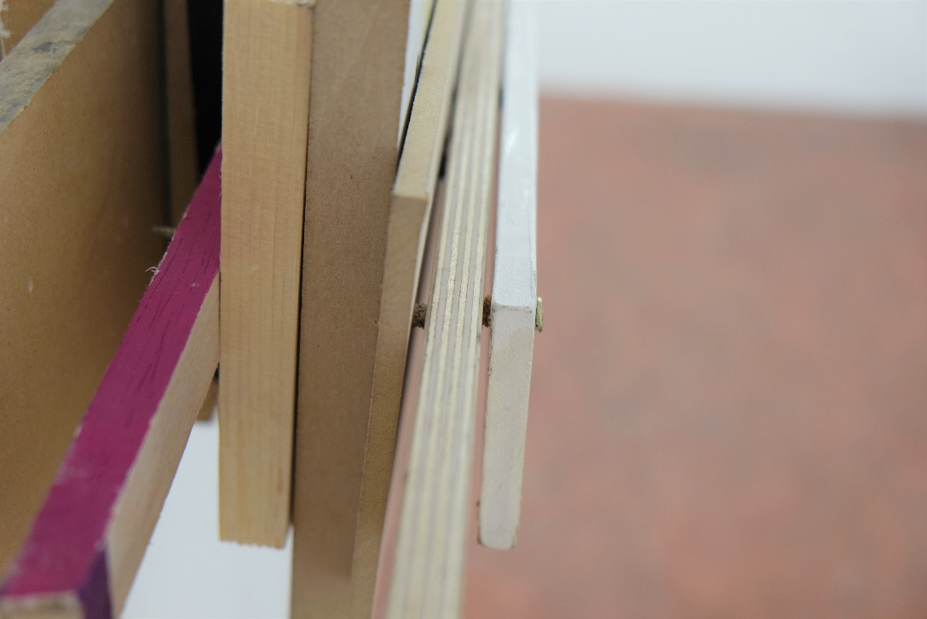
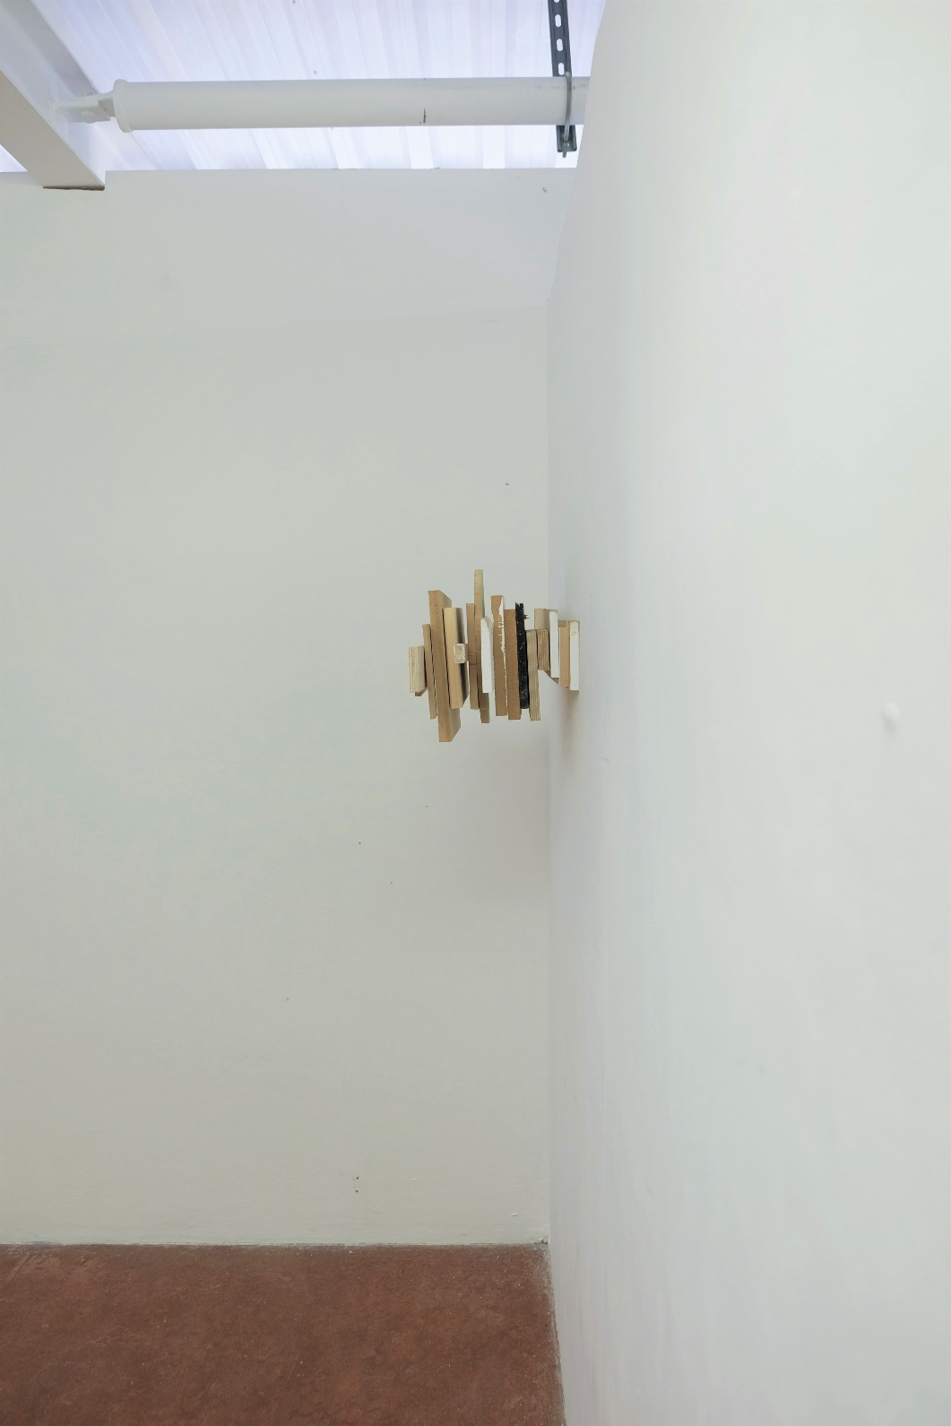
Inelegant Mobile (2017)
Bamboo and nylon rope. Approx 3m x 2m
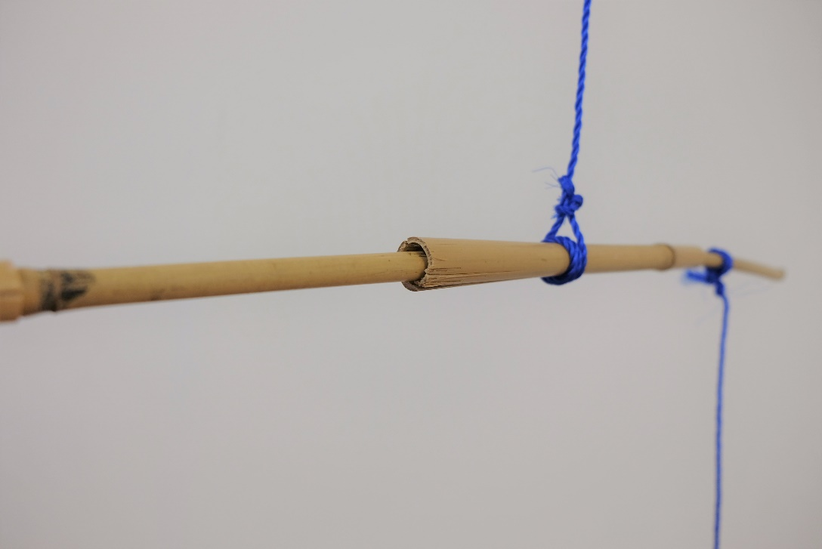
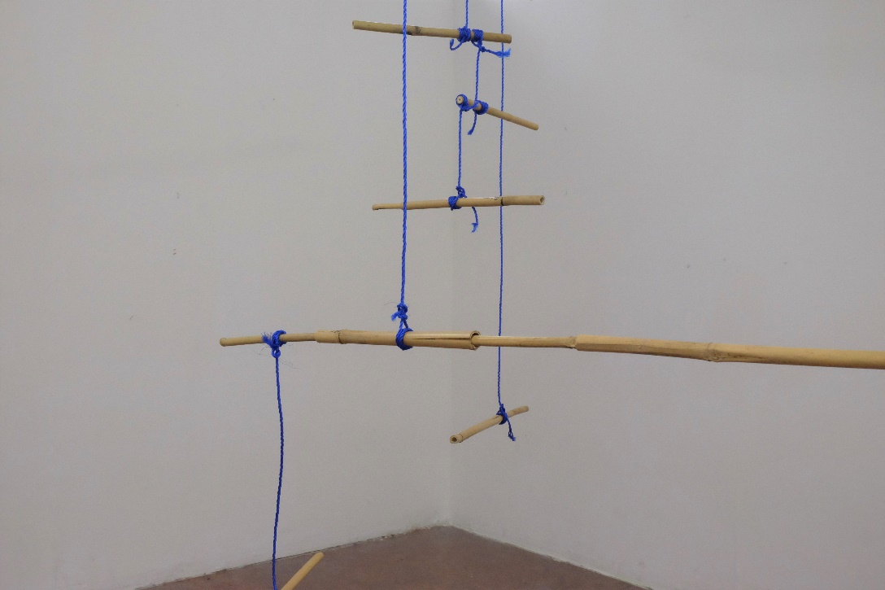
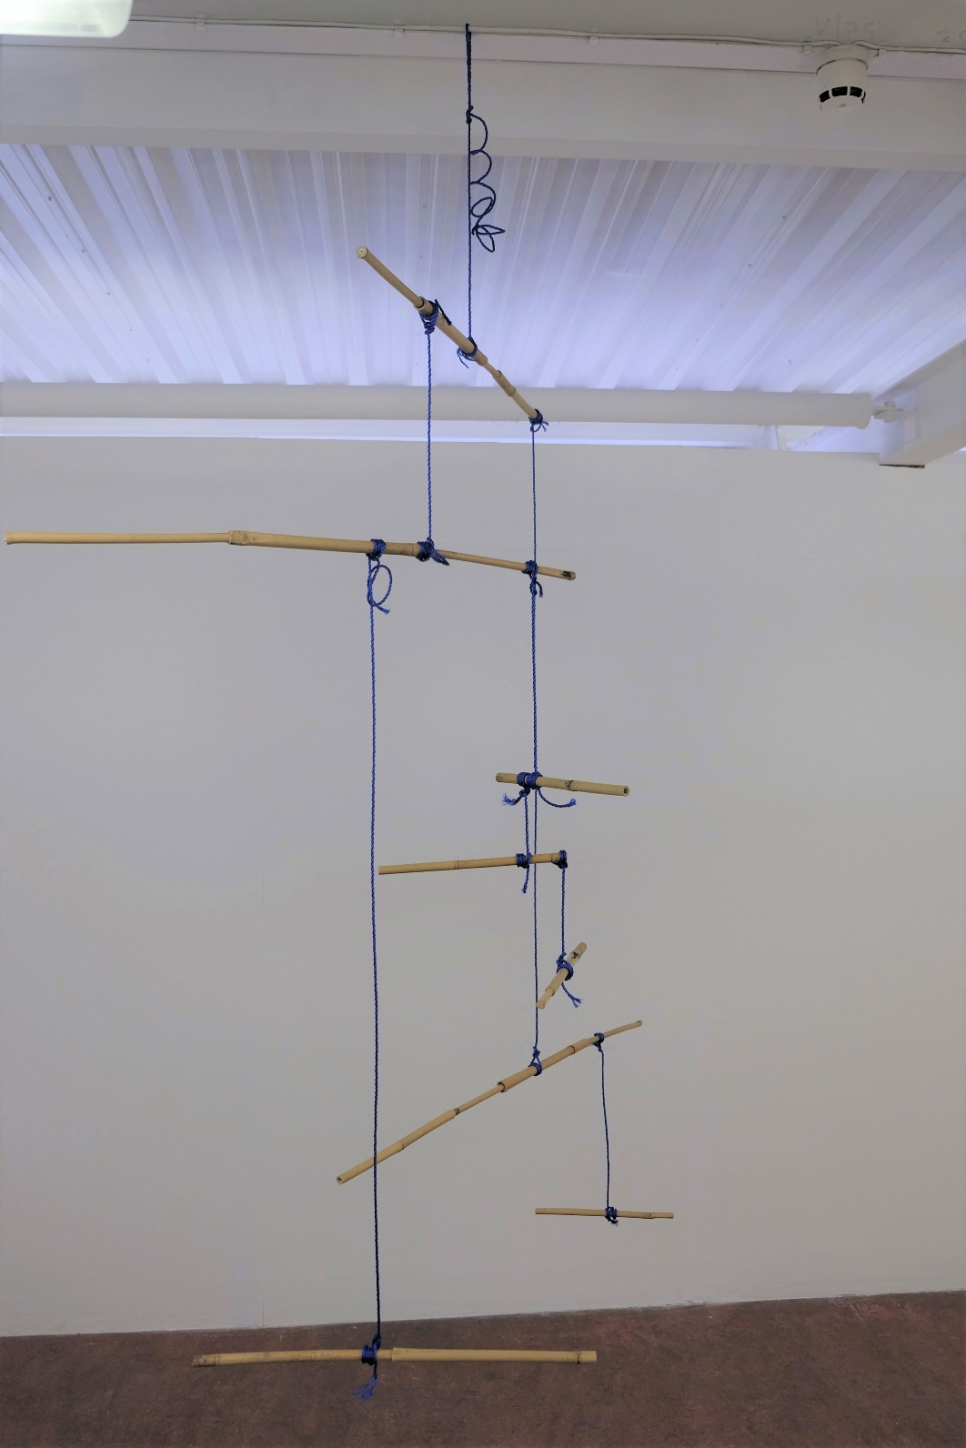

Up Their Sleeves (2017)
Set of two photo prints. Approx 4 x 6in

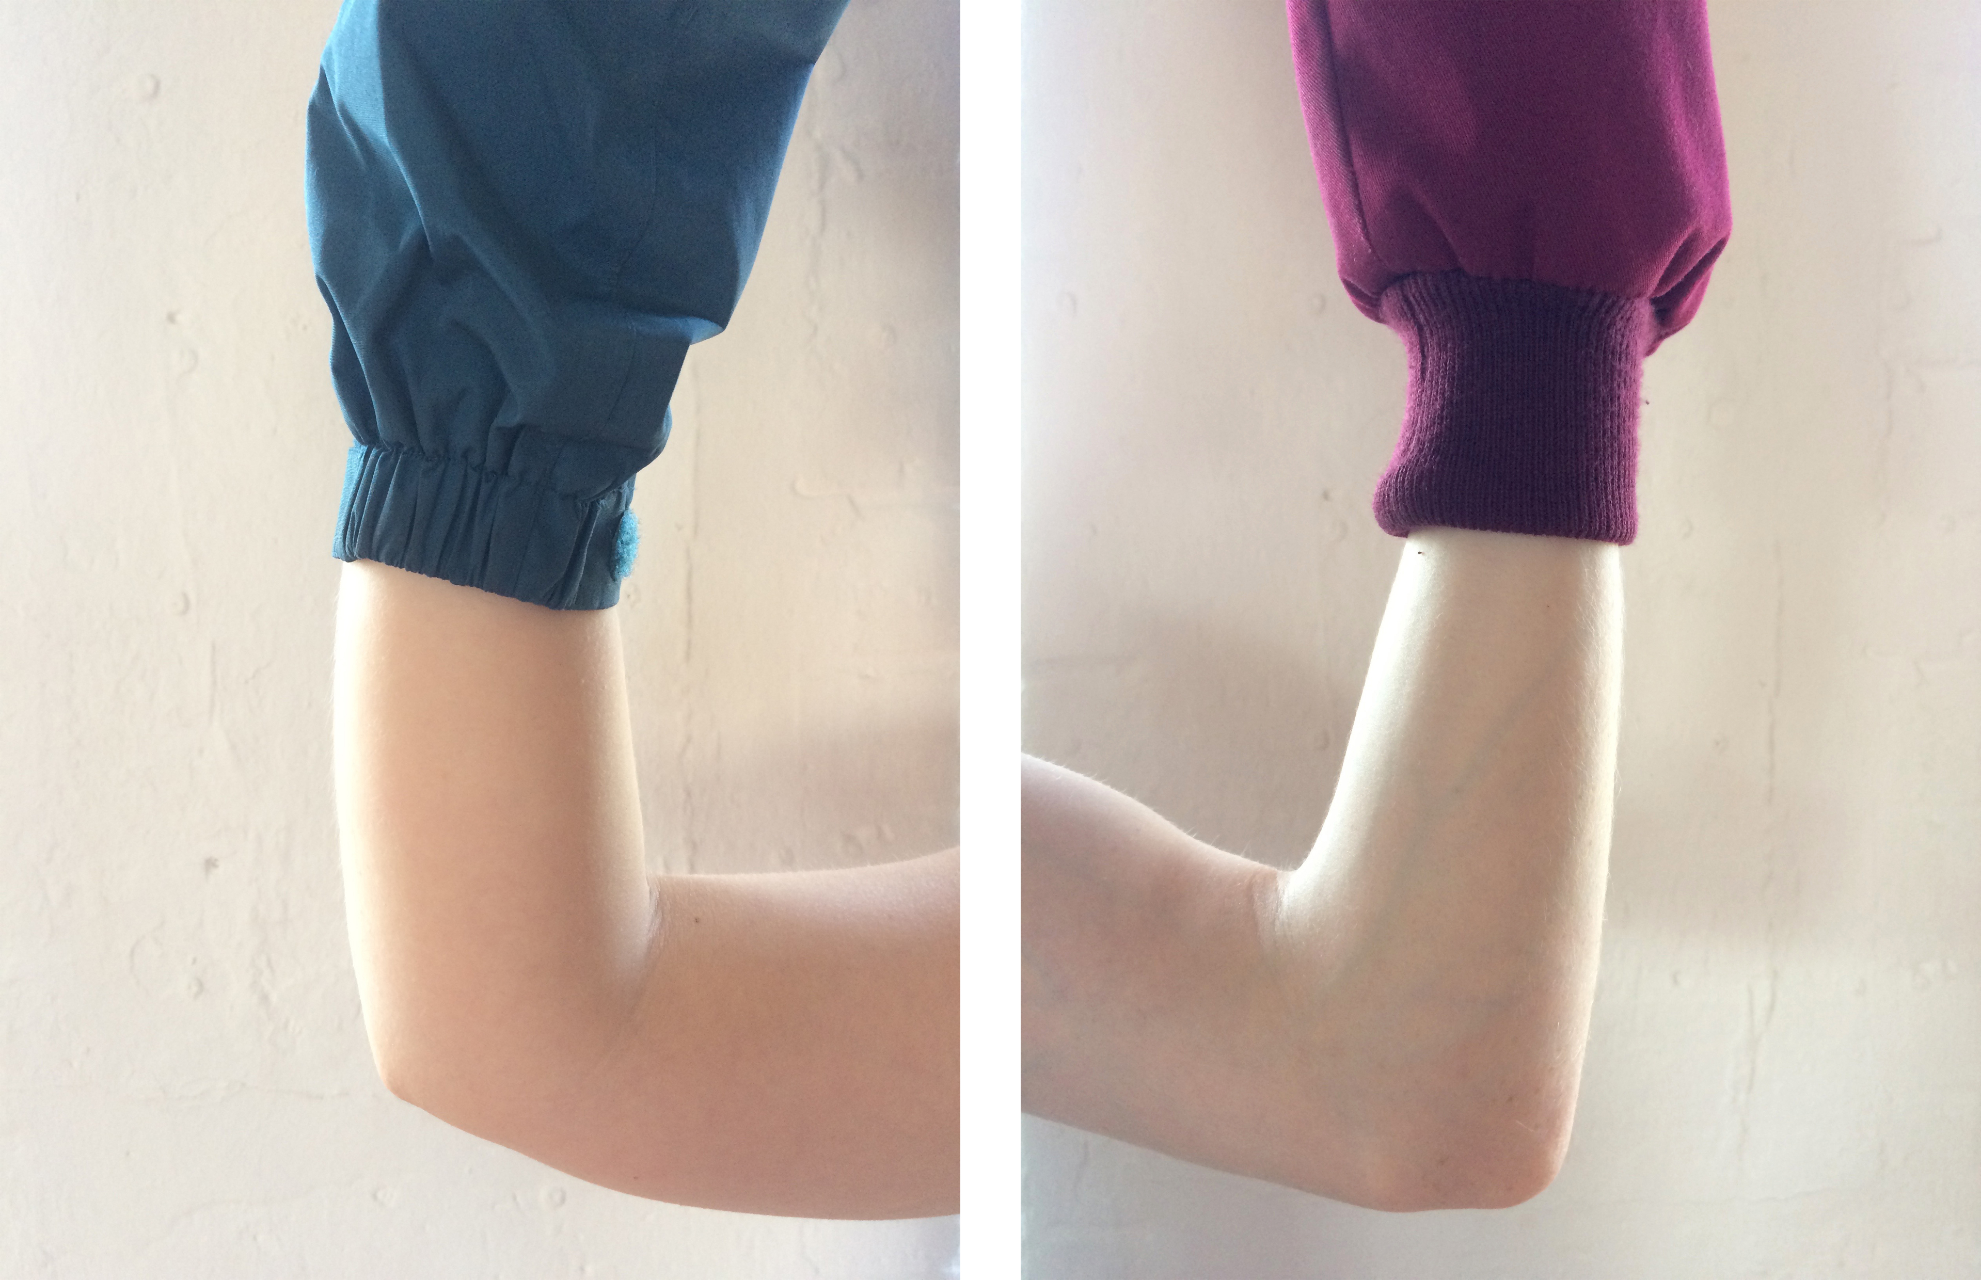
It’s Out of Our Hands (2017)
Video, single channel, sound, 1min 30
Available online here: https://vimeo.com/217874112

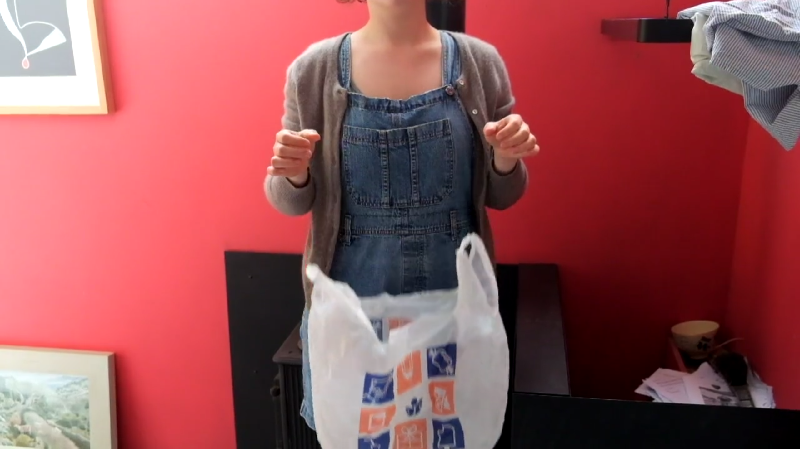

Untitled Score for Two Performers (2017)
Live performance. 25 mins, for a standing audience. Two performers simultaneously shout and read out pre-prepared lists of names, gradually exhausting the act of naming and the materiality of the human voice.

